Project Design Phase-II
Technology Stack (Architecture & Stack)

Date | 02 October 2026
Team ID | SWTID-2026-6255
Project Name | AI FAQ Assistant API
Maximum Marks | 4 Marks

Technical Architecture:
The Deliverable shall include the architectural diagram as below and the information as per the table1 & table 2
AI FAQ Assistant API - Architecture Diagram
Reference: https://fastapi.tiangolo.com/
Guidelines:
Include all the processes (As an application logic / Technology Block)
Provide infrastructural demarcation (Local / Cloud)
Indicate external interfaces (third party API’s etc.)
Indicate Data Storage components / services
Indicate interface to machine learning models (if applicable)
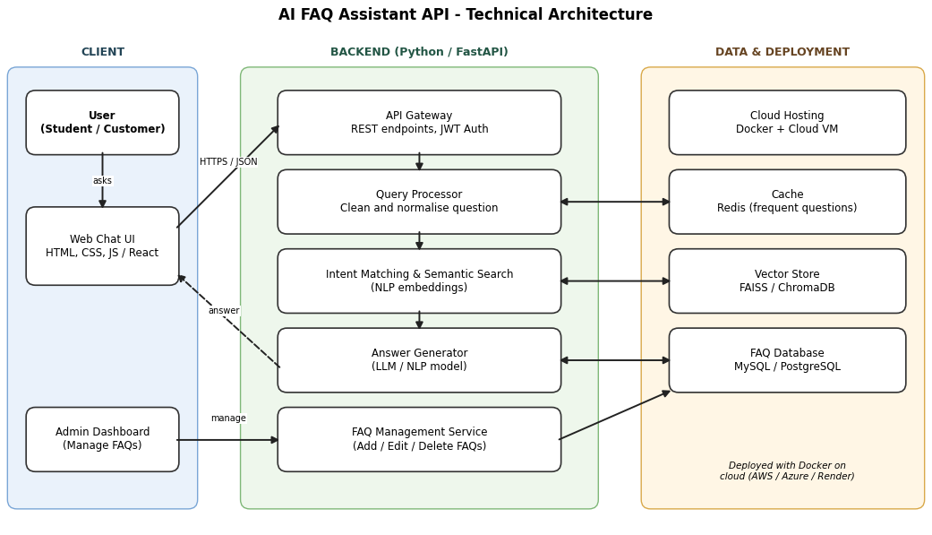

Table-1 : Components & Technologies:
S.No | Component | Description | Technology
 | User Interface | Web chat page where users type questions and read answers; admin dashboard to manage FAQs | HTML, CSS, JavaScript / React JS
 | Application Logic-1 | REST API for user login, receiving questions and returning answers | Python, FastAPI
 | Application Logic-2 | Cleans the question and finds the most relevant FAQ using semantic search | NLP (spaCy / NLTK), Sentence-Transformers
 | Application Logic-3 | Builds the final answer from the matched FAQ, adds a confidence score and returns a fallback message if no match | Python, LLM API
 | Database | Stores FAQs, categories, users, chat history and feedback | MySQL / PostgreSQL
 | Cloud Database | Managed database service on cloud for production data | Amazon RDS (PostgreSQL) / Google Cloud SQL
 | File Storage | Storage for uploaded FAQ files (CSV / PDF) and vector index files | AWS S3 or Local Filesystem
 | External API-1 | Large Language Model API used to write natural-language answers from FAQ content | OpenAI API / Google Gemini API / Claude API
 | External API-2 | Sign-in and registration through Gmail | Google OAuth 2.0 API
 | Machine Learning Model | Converts FAQs and user questions into embeddings to find the closest matching FAQ | Sentence-BERT (all-MiniLM-L6-v2), FAISS
 | Infrastructure (Server / Cloud) | Application deployment on Local System / Cloud  Local Server Configuration: Python 3.11, 8 GB RAM, 4-core CPU  Cloud Server Configuration: 2 vCPU, 4 GB RAM, Ubuntu VM | Local, Docker, Render / AWS EC2

Table-2: Application Characteristics:
S.No | Characteristics | Description | Technology
 | Open-Source Frameworks | Open-source frameworks used: FastAPI (API), React JS (UI), Sentence-Transformers (embeddings), FAISS (vector search), SQLAlchemy (database) | FastAPI, React JS, Sentence-Transformers, FAISS
 | Security Implementations | JWT authentication, role-based access (user / admin), password hashing, HTTPS, input validation, API rate limiting, CORS rules and cloud firewall | JWT, bcrypt, HTTPS / TLS, OWASP Top 10
 | Scalable Architecture | 3-tier architecture (UI, API logic, data). Stateless API scales horizontally and can be split into microservices (search, answer, FAQ management) | Docker, FastAPI, 3-tier
 | Availability | Docker containers behind a load balancer with health checks and auto-restart; regular database backups | Nginx load balancer, Docker, Cloud VM
 | Performance | Cache for frequently asked questions, fast vector similarity search and async API calls; target response under 2 seconds; static UI served through a CDN | Redis, FAISS, FastAPI (async), CDN

References:
https://c4model.com/
https://huggingface.co/sentence-transformers
https://www.ibm.com/cloud/architecture
https://aws.amazon.com/architecture
https://medium.com/the-internal-startup/how-to-draw-useful-technical-architecture-diagrams-2d20c9fda90d

